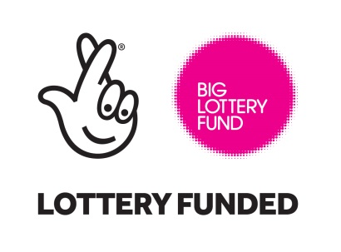

Tuesday, 10 March 2022

Dear Applicant

Job Title: Sight Loss Helpline Adviser and Head Office Administration Assistant
Thank you for enquiring about the above vacancy.
Devon in Sight is a local charity providing FREE practical help & advice to people who are blind or partially sighted to help them live life to the full.
We are committed to providing accurate and impartial Information, Advice and Guidance to people who are blind or partially sighted, their family, friends and carers.
A key part of this role is to provide the day-to-day delivery of the Helpline service. Ensuring that high quality information and exceptional listening support is provided to our clients and those affected by sight loss contacting the service.
You will also provide administrative support to the Head Office Team.
As our Sight Loss Helpline Adviser, you will take a lead role in developing and providing our Information, Advice and Guidance Service which aims to improve access to a range of holistic advice and support services for people affected by sight loss across the county.
This post is Head Office-based, but there may be a requirement to travel around the county of Devon.
An enhanced Disclosure Barring Service (DBS) certificate will be required for this role.
This role can sometimes be challenging but highly rewarding.
Sight Loss Helpline Adviser and Head Office Administration Assistant.
Hours of work: 37hrs per week Salary: £20,000
If you are self-motivated and highly organised and have a genuine interest in working with people with a visual impairment, we would love to hear from you.
Please complete the Application Form and return it to us with a covering letter. The Application Form should address the skills required to perform the role mentioned in the Job Description and Personal Specification. It should also include details of your motivation to apply for the position and, where relevant, experience of issues affecting visually impaired people.
Applications via email are welcome and may be submitted directly to jennie@devoninsight.org.uk. Alternatively, hard-copy applications should be sent for the attention of Grahame Flynn (Chief Executive Officer) at Devon in Sight, Splatford Barton, Kennford, Exeter, EX6 7XY.
The closing date for applications is noon on Monday 4th April 2022. If you haven’t heard from us by Friday 15th Aril 2022, you should assume that you have not been shortlisted on this occasion. I am sorry that it will not be possible for us to acknowledge every application.
Interviews will be held on Thursday 21st April 2022.
Devon in Sight is committed to equality and diversity. We welcome applicants regardless of racial, ethnic or national origin, religion or beliefs, disability, sexuality, age or responsibilities for dependents. Please complete the equal opportunities form.
We are committed to safeguarding and promoting the welfare of children, young people and vulnerable adults. The successful applicant will be subject to an Enhanced Disclosure & Barring Service check.
Please do let us know if you need this information sent to you in a different format. If you have any questions about our vacancy, please do not hesitate to call Jennie Benham our Office Manager on 01392 878 802.

If you would like to an informal chat about the role you can also reach me on the telephone number above.
For further information about the charity please visit our website: www.devoninsight.org.uk

Thank you for your interest.
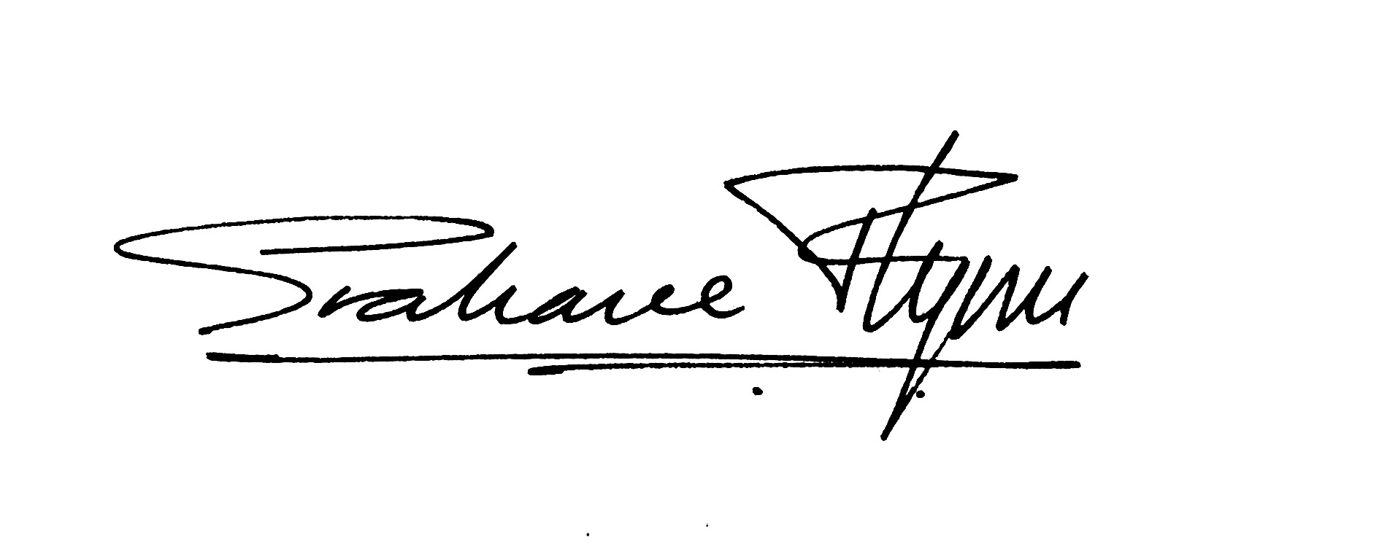
Yours sincerely,

Grahame Flynn
Chief Executive Officer
Devon in Sight

Background Information

The Devon in Sight staff team is composed of three full time members of staff and five head office volunteers, who are based at Splatford Barton, Kennford, Exeter, EX7 6XY. We also have three consultants who are all home based.

The Chief Executive Officer is ultimately responsible for the day to day running of the Charity and reports to the Chair of the Board.

The Charity is totally independent, although we work very closely with a variety of agencies. We are registered both as a Charity and as a company, and our Trustees/Directors who make up the Board have ultimate responsibility for the finances of the Charity and our strategy and direction. They meet quarterly.

Our Mission:

“We are a local charity providing practical help and advice to people affected by sight loss, to maximise their independence, wellbeing and choice.”

Our Vision:

To be a ‘Centre of Excellence’ for people in Devon affected by sight loss

Our Strategy:

- Develop effective working partnerships with key organisations to ensure that we have a clear care pathway for people with sight loss in Devon.
- Demonstrate the impact of our services with outcome monitoring
- Attract funding from individuals, trusts and other grant makers by doing a great job for people with sight loss.
- Carefully manage all expenditure.
- Look creatively at how we deliver services in the future.

Our Values:

- We strive to provide the best possible service.
- We put people with sight loss at the centre of everything we do.
- We work in partnership with other service providers.
- We respect, trust and support our staff.
- We strive to be totally trustworthy.

