Community Support Service Summary

Devon in Sight launched an award winning Community Support Service in January 2017 which will increase the independence, wellbeing and choice of people with sight loss across much of Devon.

The service, which will cost a total of £641,000 over four years will provide practical and emotional support from a number of new ‘Community Sight Loss Hubs’ in East Devon, Mid Devon, West Devon and Torbay which will enable people with sight loss to access the full range of services which are available from Devon in Sight and other voluntary and statutory sector organisations.

Clinics at each of the Sight Loss Hubs will provide:
- Information, advice and training on Low Vision Aids from our Sight Loss Adviser.
- ‘Talk and Support’ groups run by volunteers to provide emotional support for people newly diagnosed with sight loss.
- New Skills for Seeing Training for people with Central Vision Loss to make best use of their residual sight.
- Groups, and individual support, from voluntary and statutory sector partners. including Action for Blind People, the RNIB, the Macular Society, Guide Dogs, Blind Veterans UK, MoorVision, Action on Hearing Loss, SENSE for Deafblind people, and the local authority Sensory Team.

A Community Support Worker in each locality provides:
- An initial ‘Sight Loss MOT’ will highlight what support people need.
- Recruitment and training of volunteers to provide emotional support and practical help for people at home and in the community.
- Specific advice, training and support for people with sight loss on a range of key issues such as falls prevention, keeping safe and warm at home, accessing allowances and entitlements through registration as being sight impaired, nutrition and exercise, and maintaining eye health.

We will also be developing a programme of Community Engagement:
- We will support existing local groups and clubs which build peer support for people with sight loss.
- We will organise sight loss awareness sessions with community groups to raise awareness of sight loss issues and prevention. These will be delivered with people with sight loss as volunteers.
- We will develop local Sight Loss Reference Groups to enable people with sight loss to influence the commissioning of local sight loss services.

“This is likely to be a best-practice model of service delivery which should promote meaningful collaboration among partner organisations. Thank you for taking the lead in this impressive way. I hope that your project is successful and we look forward to working together.” Nick Caplin, CEO Blind Veterans UK.

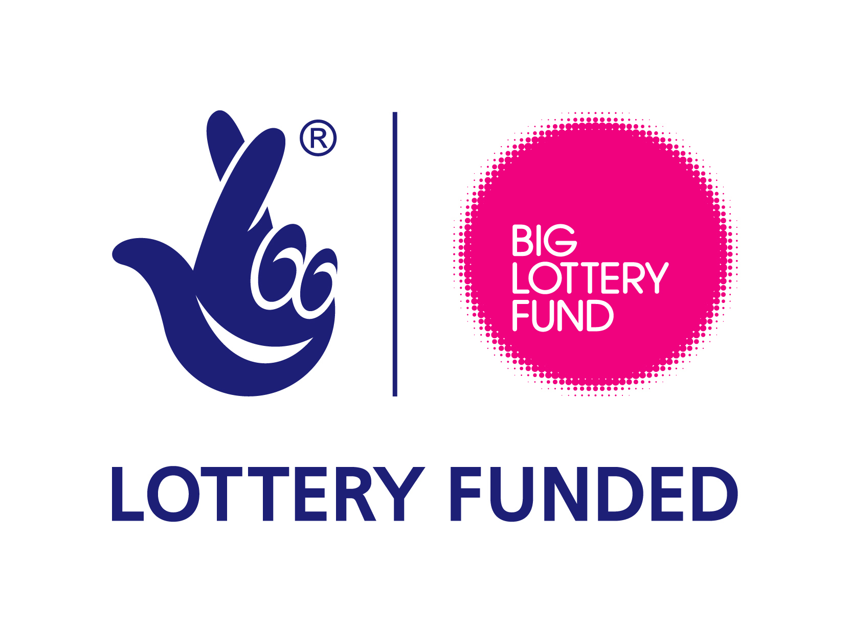
We are delighted to have received a grant of £420,000 from the
BIG Lottery Fund towards the new Community Support Service.
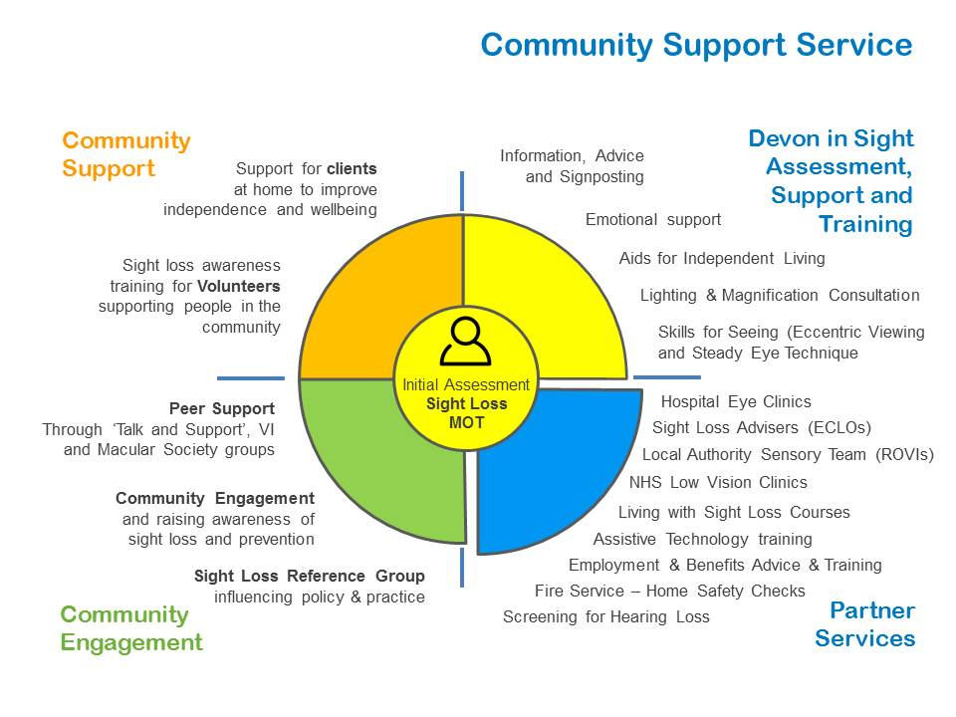

Community Support Hubs 2019


